app.py

|  |
| --- |
| from flask import Flask, render_template  app = Flask(__name__, static_url_path='/static', static_folder='static')  app = Flask(__name__)  @app.route('/')  def index():  return render_template('index.html')  if __name__ == '__main__':  app.run(host='0.0.0.0', debug=True) |

Index.html

|  |
| --- |
| <!DOCTYPE html>  <html lang="en">  <head>  <meta charset="utf-8" />  <meta name="viewport" content="width=device-width, initial-scale=1" />  <title>Restaurant Finder</title>  <!--link rel="stylesheet" href="./css/style.css"-->  <link  rel="stylesheet"  href="https://cdnjs.cloudflare.com/ajax/libs/font-awesome/6.3.0/css/all.min.css"  />  <link  href="https://cdn.jsdelivr.net/npm/bootstrap@5.3.0-alpha1/dist/css/bootstrap.min.css"  rel="stylesheet"  integrity="sha384-GLhlTQ8iRABdZLl6O3oVMWSktQOp6b7In1Zl3/Jr59b6EGGoI1aFkw7cmDA6j6gD"  crossorigin="anonymous"  />  <style>  #banner {  /* Linear gradient overlay */  background-image: url("https://hips.hearstapps.com/hmg-prod/images/table-filled-with-large-variety-of-food-shot-from-royalty-free-image-1659038707.jpg?crop=1xw:0.84335xh;center,top&resize=1200:*"), linear-gradient(#00000099, #00000099);  width: 100%;  height: 85vh;  background-size: cover;  background-repeat: no-repeat;  background-blend-mode: overlay;  }  #search-section {  width: 60%;  height: 40px;  position: relative;  margin-top: 40px;  }  #search-section input {  width: 100%;  height: 100%;  border-radius: 5px;  outline: none;  border: none;  padding: 10px 35px;  }  #search-section i {  position: absolute;  top: 12px;  left: 10px;  }  #search-section button {  position: absolute;  height: 100%;  top: 0;  right: 0;  font-weight: bolder;  }  main {  margin-top: 40px;  font-weight: bold;  }  #cards {  display: grid;  grid-template-columns: repeat(3, 1fr);  gap: 30px;  }  .card {  width: 100%;  }  .card-img {  object-fit: cover;  width: 100%;  height: 100%;  }  .modal-body {  height: 70vh;  }  .modal-body::-webkit-scrollbar {  display: none;  }  .modal-body {  overflow-x: auto;  }  @media (max-width: 900px) {  #cards {  grid-template-columns: repeat(2, 1fr);  }  }  @media (max-width: 600px) {  #search-section {  width: 98%;  }  #cards {  grid-template-columns: repeat(1, 1fr);  }  .sign-up {  display: block;  margin-top: 20px;  margin-bottom: 10px;  }  }  </style>  </head>  <body>  <header>  <nav class="navbar navbar-expand-lg">  <div class="container">  <a class="navbar-brand" href="#">  <h2>Restaurant Finder</h2>  <!--img src="./images/Tasty_HUT.png" alt="IMAGE"-->  </a>  <button  class="navbar-toggler"  type="button"  data-bs-toggle="collapse"  data-bs-target="#navbarNav"  aria-controls="navbarNav"  aria-expanded="false"  aria-label="Toggle navigation"  >  <span class="navbar-toggler-icon"></span>  </button>  <div class="collapse navbar-collapse" id="navbarNav">  <ul class="navbar-nav ms-auto">  <li class="nav-item">  <a  class="nav-link btn btn-warning sign-up"  aria-current="page"  href="#"  >Sign Up</a  >  </li>  </ul>  </div>  </div>  </nav>  <!-- banner -->  <section  id="banner"  class="d-flex flex-column justify-content-center align-items-center"  >  <div class="container">  <h1 class="text-center text-white">  Taste Our Delicious <br />Best Foods  </h1>  <!--p class="text-center text-white">  There are many variations of passages of Lorem Ipsum available, but  the majority have <br />  suffered alteration in some form, by injected humou.  </p-->  <div class="mx-auto" id="search-section">  <input type="text" id="search-input" autocomplete="off" />  <i class="fa-solid fa-magnifying-glass"></i>  <button class="btn btn-warning" id="search-btn">search</button>  </div>  </div>  </section>  </header>  <!-- main contains -->  <main>  <h2 class="text-center">Your Favourite Food</h2>  <section id="cards" class="container"></section>  <!-- madal -->  <!-- Button trigger modal -->  <!-- Modal -->  <div  class="modal fade"  id="staticBackdrop"  data-bs-backdrop="static"  data-bs-keyboard="false"  tabindex="-1"  aria-labelledby="staticBackdropLabel"  aria-hidden="true"  >  <div class="modal-dialog">  <div class="modal-content">  <div class="modal-header">  <h1  class="meal-title modal-title fs-5"  id="staticBackdropLabel"  ></h1>  <button  type="button"  class="btn-close"  data-bs-dismiss="modal"  aria-label="Close"  ></button>  </div>  <div class="modal-body">...</div>  <div class="modal-footer">  <button  type="button"  class="btn btn-secondary"  data-bs-dismiss="modal"  >  Close  </button>  </div>  </div>  </div>  </div>  <!-- show all btn -->  <div class="container d-flex justify-content-center mt-5 pb-5">  <button class="btn btn-warning" id="show-all-btn">Show All</button>  </div>  </main>  <!-- -------------------------------------------------JAVASCRIPT****************-->  <script>  console.log("HELLO WORLD")  let searchValue;  const showDetails = async (id) => {  try {  let url = `https://www.themealdb.com/api/json/v1/1/lookup.php?i=${id}`  let response = await fetch(url);  let data = await response.json();  let title = document.querySelector(".meal-title");  let body = document.querySelector(".modal-body");  console.log(data)  title.innerText = `${data.meals[0].strMeal}`  body.innerHTML = `<img class="img-fluid" src="${data.meals[0].strMealThumb}">  <p class="mt-5">${data.meals[0].strInstructions}</p>  `  } catch (err) {  alert("something is wrong")  }  }  const showMealCard = async (mealName, show = 6) => {    try {  const url = `https://www.themealdb.com/api/json/v1/1/search.php?s=${mealName}`;  const response = await fetch(url);  const data = await response.json();  const cards = document.getElementById("cards");  let meals = data.meals;  console.log(data)  console.log(meals)  cards.innerHTML = "";  let showMeals = show === true ? meals.length : meals.length < 6 ? meals.length : show;  for(let i = 0; i < showMeals; i++) {  let card = document.createElement("div");  card.innerHTML = `  <div class="card mb-3 " style="max-width: 540px">  <div class="row g-0">  <div class="col-md-4">  <img  src="${meals[i].strMealThumb}"  class="card-img"  alt="..."  />  </div>  <div class="col-md-8">  <div class="card-body">  <h5 class="card-title">${meals[i].strMeal}</h5>  <p class="card-text">  ${meals[i].strTags === null ? meals[i].strMeal : meals[i].strTags}  </p>  <button onclick="showDetails(${meals[i].idMeal})" type="button" class="btn btn-primary" data-bs-toggle="modal" data-bs-target="#staticBackdrop">Details</button>  </div>  </div>  </div>  </div>  `  cards.appendChild(card)  }  } catch (err) {  alert("please inter valid name");  }  }  const searchMeal = () => {  const input = document.getElementById("search-input");  const inputValue = input.value;  showMealCard(inputValue,);  searchValue = inputValue;    }  const searchBtn = document.getElementById("search-btn");  searchBtn.addEventListener("click", searchMeal)  const showAllBtn = document.getElementById("show-all-btn");  showAllBtn.onclick = () => {  showMealCard(searchValue, true);  }  </script>  </body>  </html> |

dockerfile

|  |
| --- |
| # syntax=docker/dockerfile:1  FROM python:3.8-slim-buster  WORKDIR /app  COPY requirements.txt requirements.txt  RUN pip3 install -r requirements.txt  COPY . .  CMD ["python3", "-m" , "flask", "run", "--host=0.0.0.0"] |

docker image build -t marketplace .

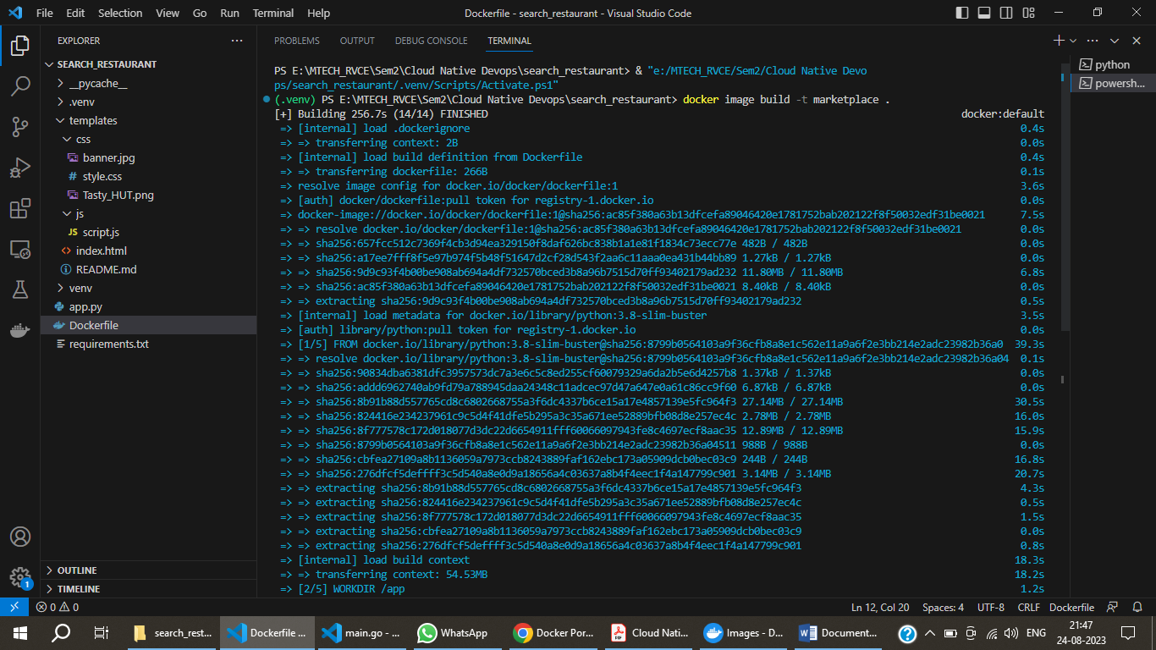

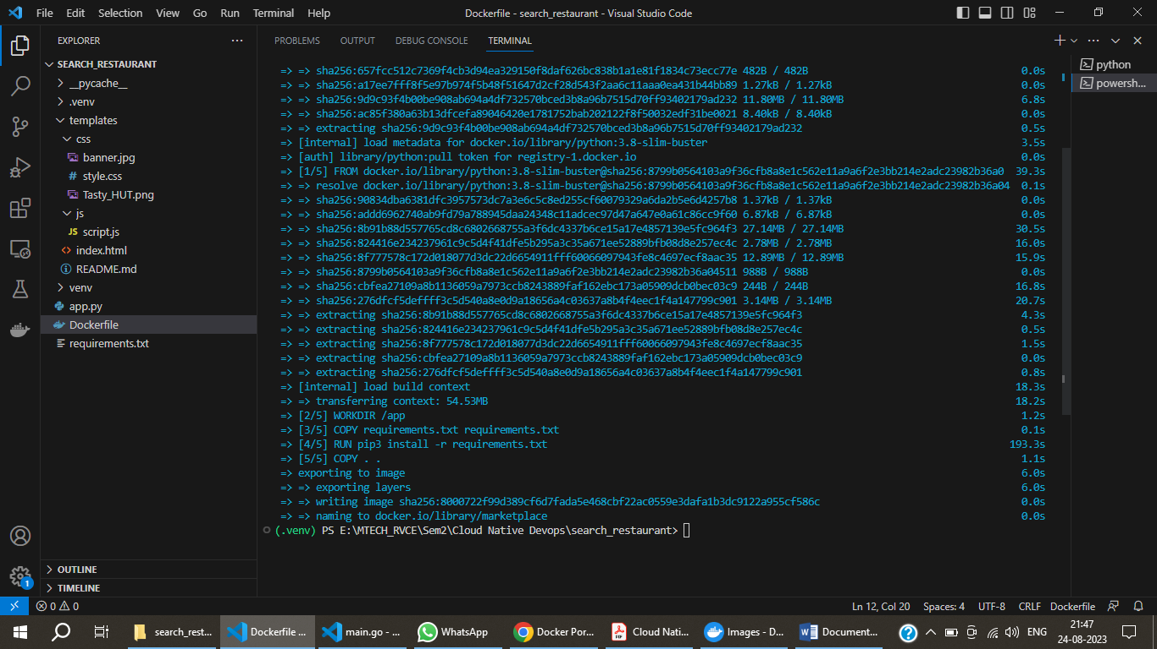

docker container run -p 9999:5000 marketplace

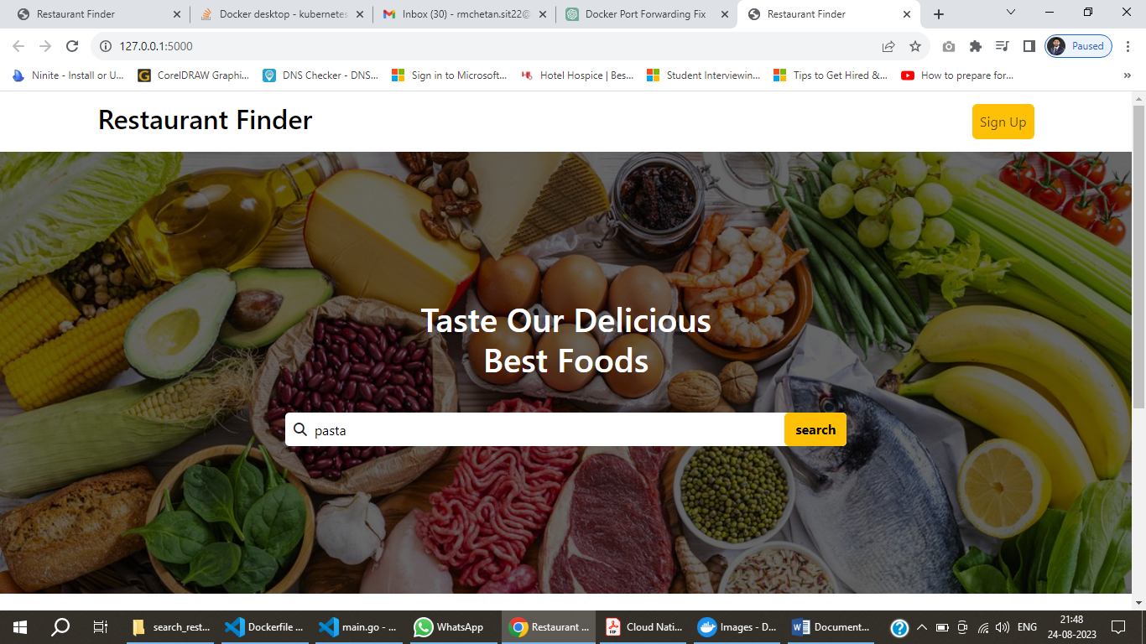

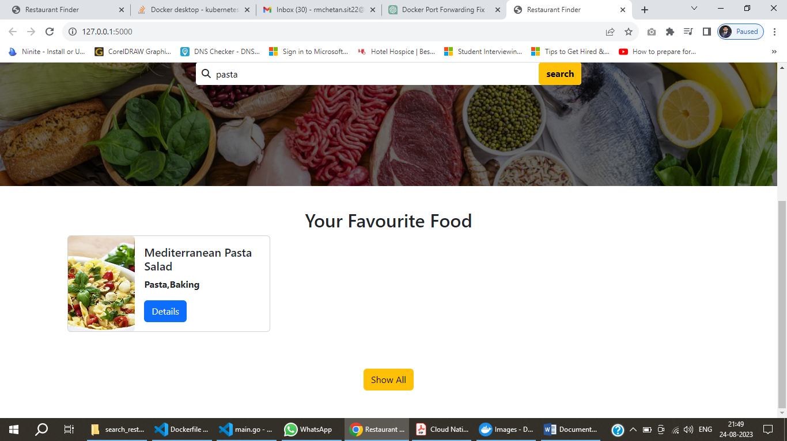

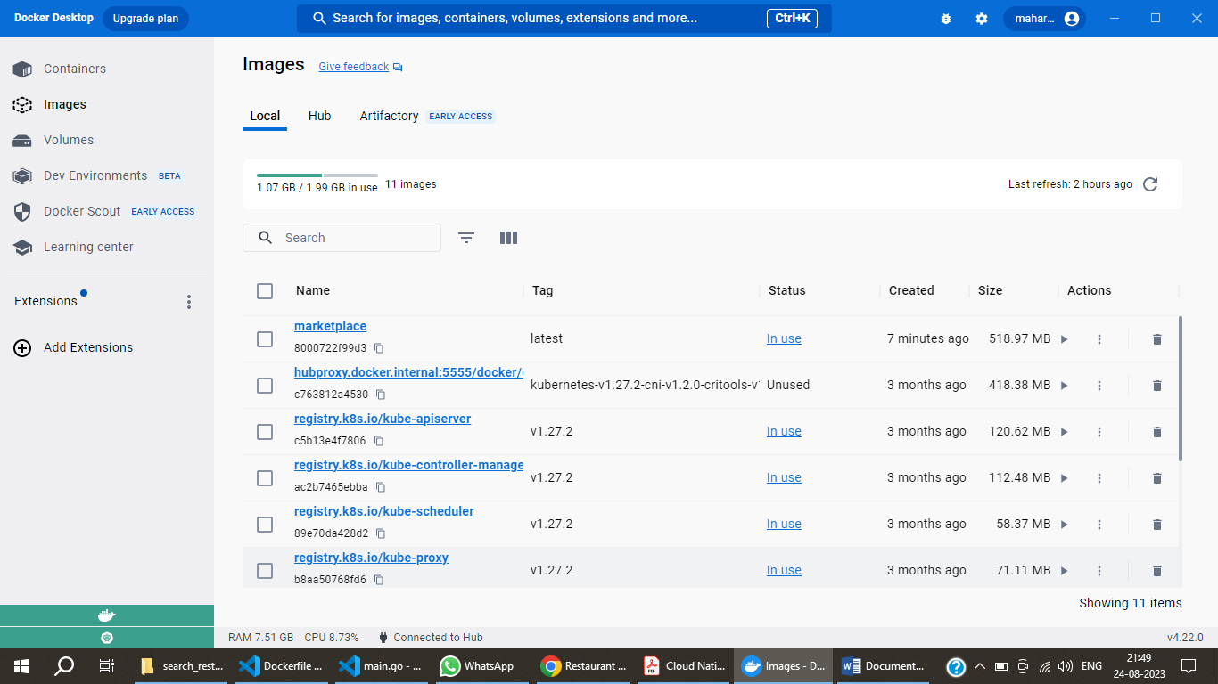

Port Forwarding

docker container run -p 8080:5000 marketplace

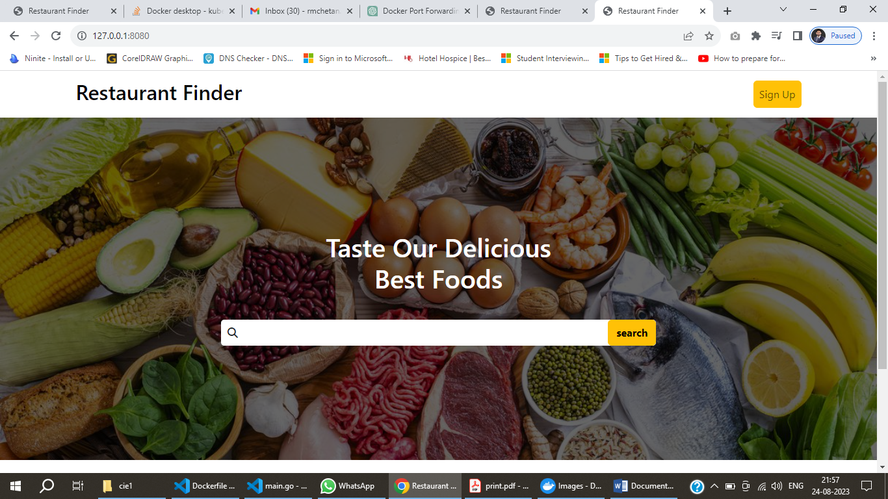

Pipeline Initialized

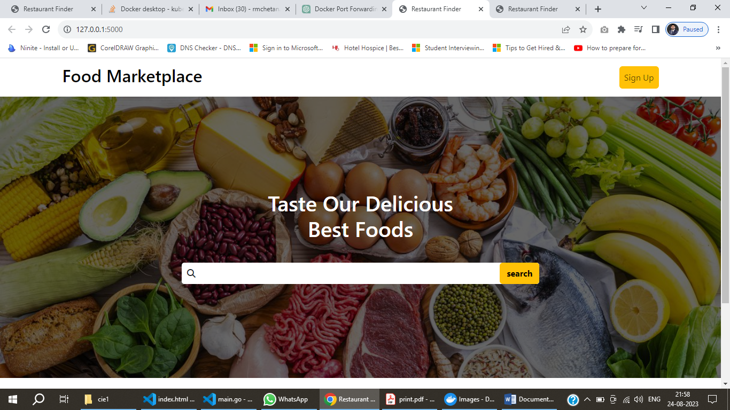

Docker Login

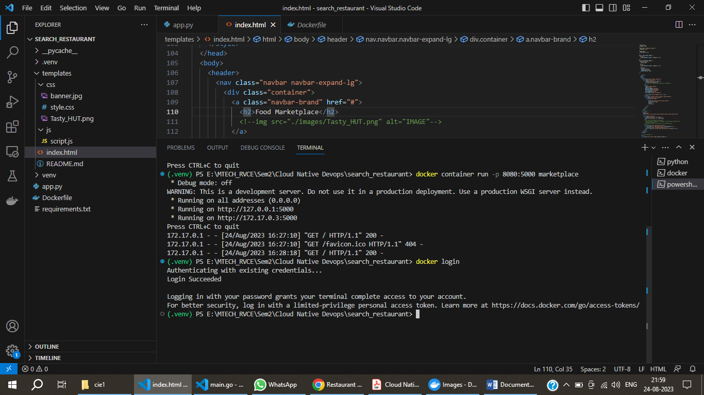

Naming and Pushing the Image

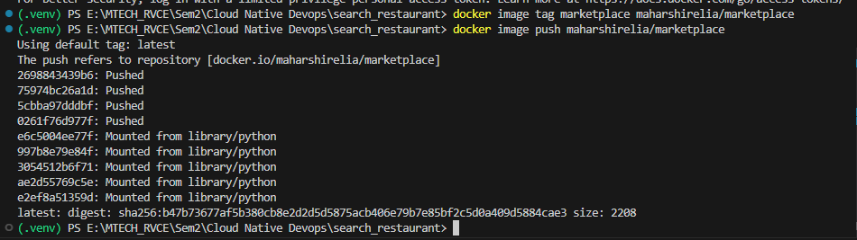

Running the Image

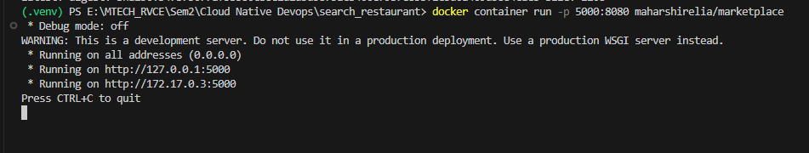

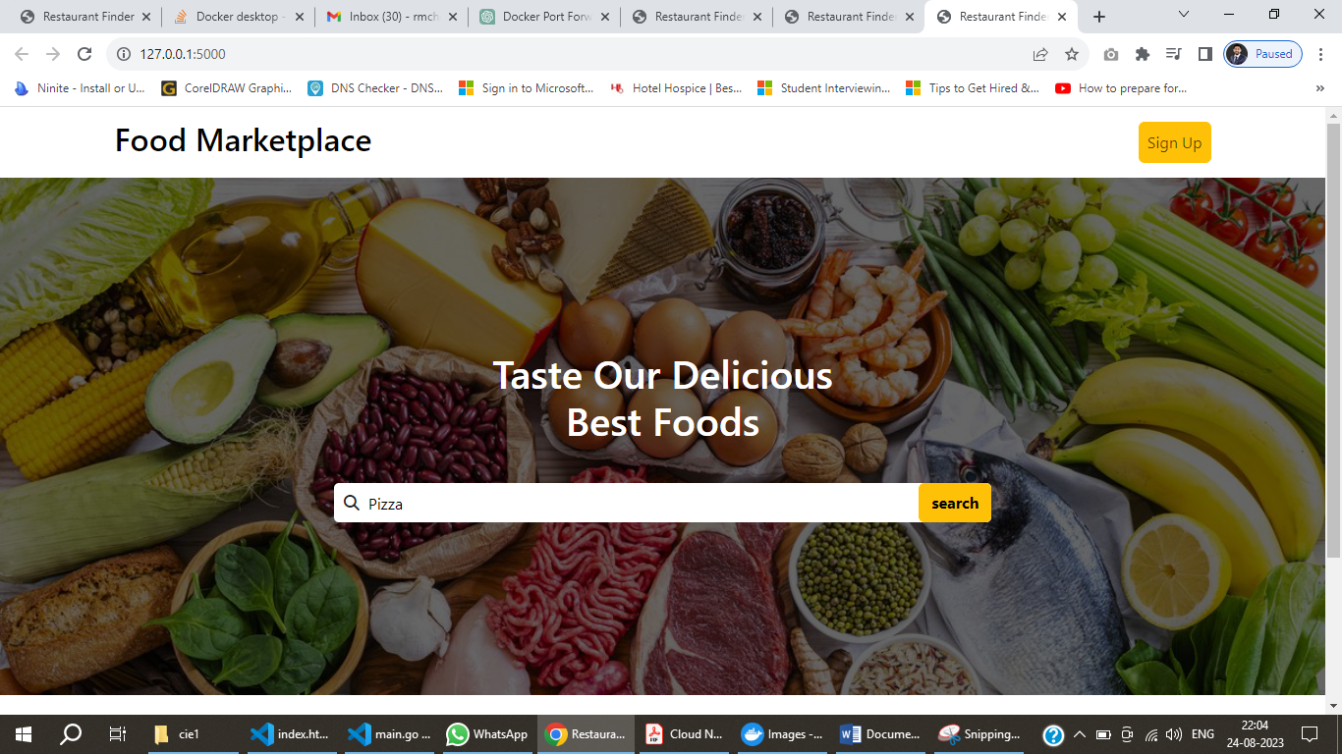

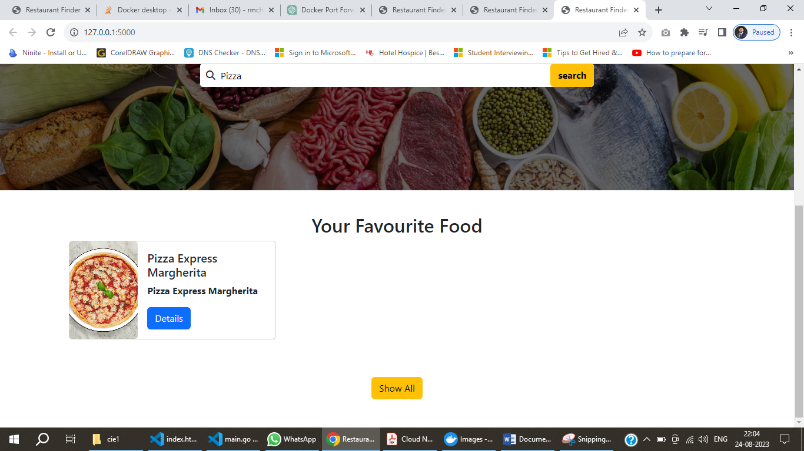

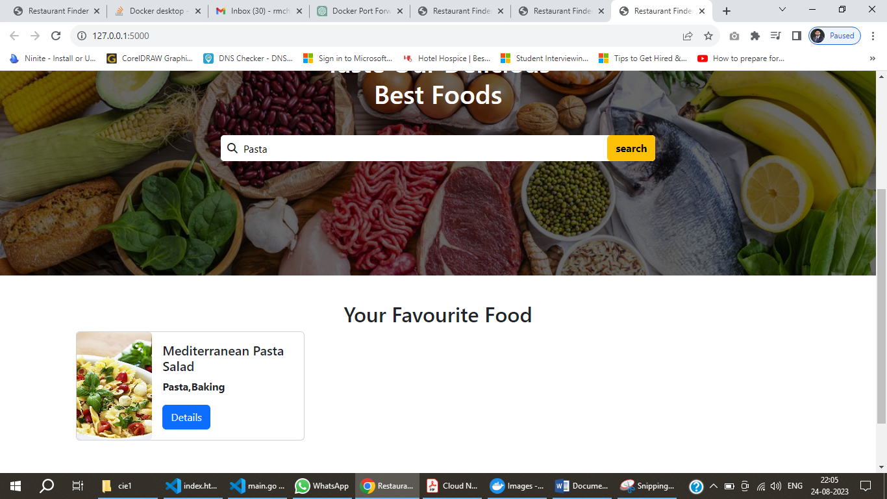

Kubernetes



Port Forwarding

kubectl port-forward pod/marketplace 8080:5000

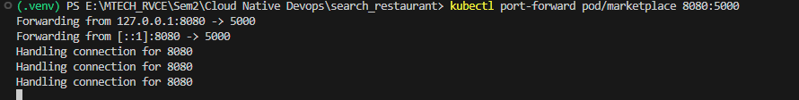

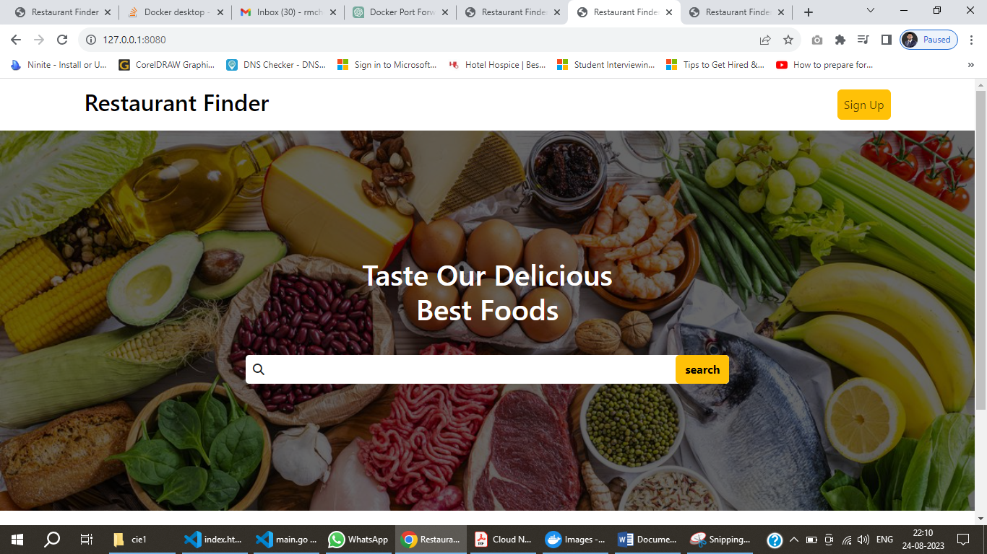

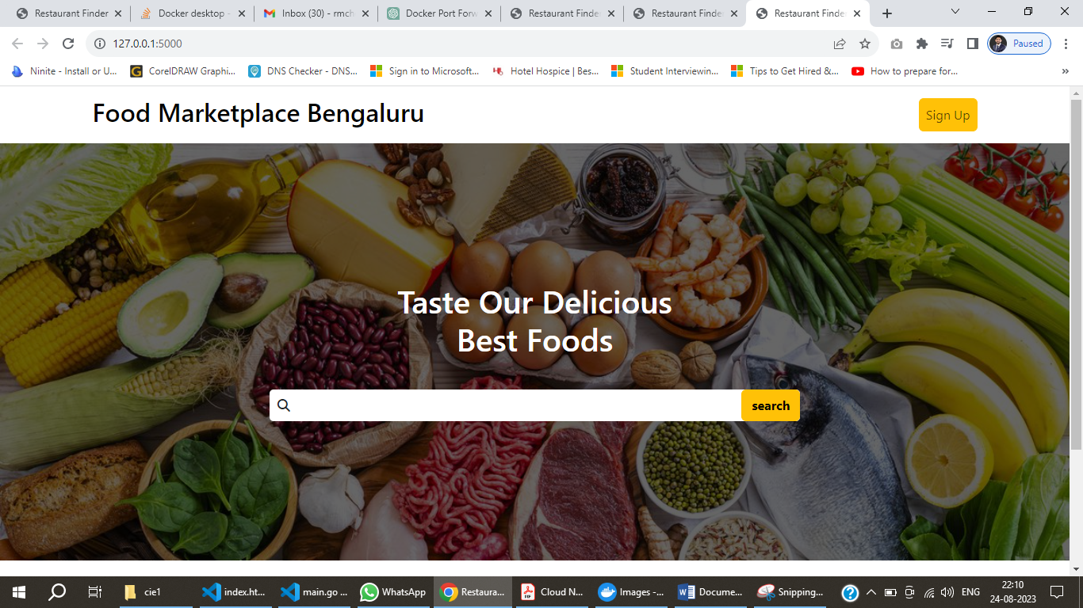



Creating Deployments



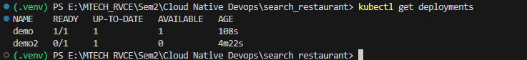

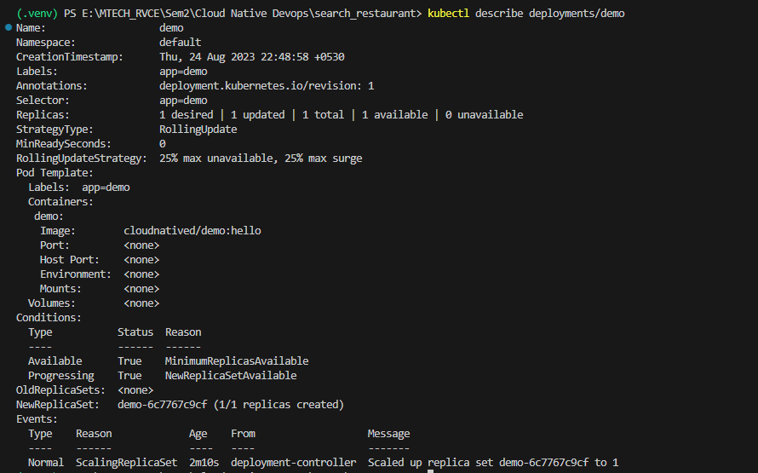

Maintaining Desired State

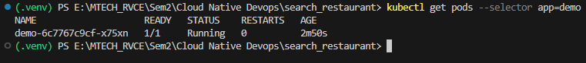



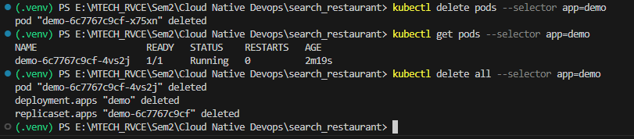

---

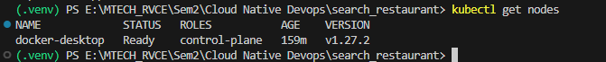

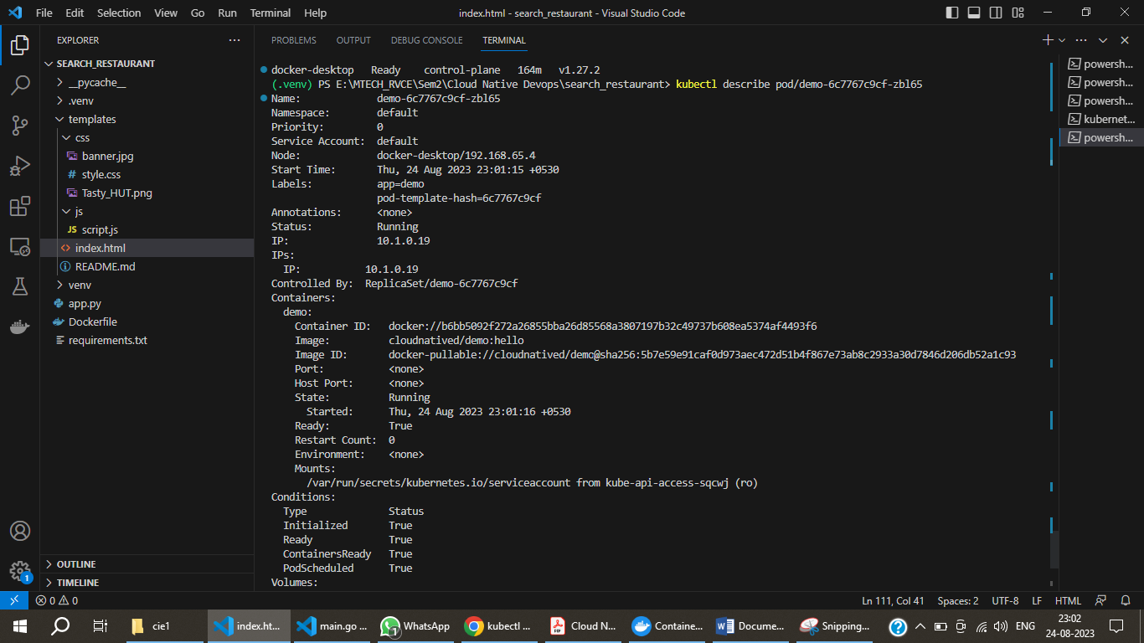

Yaml

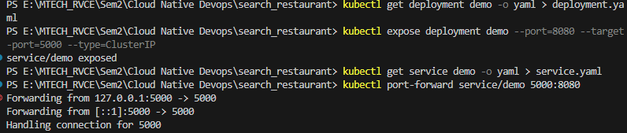

Helm

